

**Veer Narmad South Gujarat University, Surat.**

**Department of Information and Communication Technology**

**M.Sc. (Information and Communication Technology) Programme**

Project Report

**3rd Semester**

**M.Sc. (Information and Communication Technology) 2-Year Course**

**Year 2024 – 2025**

**Subscription Management System**

|  |  |
| --- | --- |
| Guided By:  **Mr. Sunny Chevli (External Guide) Dr. Payal Joshi (Internal Guide)** | Submitted By:  **Dhruvin Jariwala (R23110018000710029)**  **Meet Mistry (R23110018000710043)** |

InfoWeb Solution Company.

25, Vatsalaya Bungalow, Vesu, Surat-395007

## Department of Information and Communication Technology

**M.Sc. (Information and Communication Technology) Programme**

**Certificate**

This is to certify that Mr./Ms. **Mr.Dhruvin Jariwala** with Exam Seat Number: **1028** and Enrollment Number:

**R23110018000710029 has** worked on his/her project work entitled **Subscription Management System** At **InfoWeb Solution Company** as a partial fulfillment of the requirements for 3rd Semester ***- M.Sc. (Information and***

***Communication Technology)***, during the academic Year 2024-2025.

Date: 13/12/2024

Place: Dept. of ICT, VNSGU, Surat.

|  |  |  |
| --- | --- | --- |
| **Internal Project Guide M.Sc. (I.C.T.) 3rd Semester Department of I.C.T.**  **Veer Narmad South Gujarat University, Surat** | **Course Coordinator M.Sc. (I.C.T.) Programme Department of I.C.T.**  **Veer Narmad South Gujarat University, Surat** | **Head of the Department Department of I.C.T.**  **Veer Narmad South Gujarat University, Surat** |

## Department of Information and Communication Technology

**M.Sc. (Information and Communication Technology) Programme**

**Certificate**

This is to certify that Mr./Ms. **Mr.Meet Mistry** with Exam Seat Number: **1040** and Enrollment Number:

**R23110018000710043 has** worked on his/her project work entitled **Subscription Management System** At **InfoWeb Solution Company** as a partial fulfillment of the requirements for 3rd Semester ***- M.Sc. (Information and***

***Communication Technology)***, during the academic Year 2024-2025.

Date: 13/12/2024

Place: Dept. of ICT, VNSGU, Surat.

|  |  |  |
| --- | --- | --- |
| **Internal Project Guide M.Sc. (I.C.T.) 3rd Semester Department of I.C.T.**  **Veer Narmad South Gujarat University, Surat** | **Course Coordinator M.Sc. (I.C.T.) Programme Department of I.C.T.**  **Veer Narmad South Gujarat University, Surat** | **Head of the Department Department of I.C.T.**  **Veer Narmad South Gujarat University, Surat** |



25, Vatsalaya Bunglow, Vesu, Surat-395007 . Ph: +91 99092 84838

Date: 9th Dec, 2024

*Certificate*

This is to certify that **Dhruvin Jariwala** has successfully carried out a website development project at our institute as part of his academic activity for the J.P. Dawer Institute of Information Science and Technology - B.Sc. (IT) & M.Sc. (ICT).

During this project, he developed a **Subscription Management System** using **.NET Core**, **React Vite**, and **PostgreSQL**.

As part of our policy, we do not allow the source code or design documents to leave our premises. However, as this is an academic project, he is permitted to take some design documents for academic purposes to be presented to the authorities of your institute only.



25, Vatsalaya Bunglow, Vesu, Surat-395007 . Ph: +91 99092 84838

Date: 9th Dec, 2024

*Certificate*

This is to certify that **Meet Mistry** has successfully carried out a website development project at our institute as part of his academic activity for the J.P. Dawer Institute of Information Science and Technology - B.Sc. (IT) & M.Sc. (ICT).

During this project, he developed a **Subscription Management System** using **.NET Core**, **React Vite**, and **PostgreSQL**.

As part of our policy, we do not allow the source code or design documents to leave our premises. However, as this is an academic project, he is permitted to take some design documents for academic purposes to be presented to the authorities of your institute only.

**INDEX**

|  |  |  |
| --- | --- | --- |
| **No.** | **Description** | **Page No.** |
| **1** | **Introduction:** | **1** |
| **1.1: - Company Profile** |
| **1.2: - Customer Profile** |
| **1.3: - Current System** |
| **2** | **Proposed System** | **5** |
| **2.1: - Scope** |
| **2.2: - Objective** |
| **2.3: - Constraints** |
| **2.4: - Advantages** |
| **2.5: - Limitations** |
| **3** | **Environment Specification** | **9** |
| **3.1: - Hardware & Software Requirements** |
| **3.2: - Development Description** |
| **4** | **System Planning** | **12** |
| **4.1: - Feasibility Study** |
| **4.2: - Software Engineering Model** |
| **4.3: - Risk Analysis** |
| **5** | **System Analysis** | **16** |
| **5.1 Detailed SRS** |
| **5.2 UML Diagrams** |
| **5.3 Class Diagram** |
| **5.4 E-R Diagram** |
| **6** | **Software Design** | **27** |
| **6.1 :- Database Design** |
| **6.2 :- Snapshot for the site** |
| **7** | **Testing** | **46** |
| **7.1 Unit Testing** |
| **7.2 Integration Testing** |
| **8** | **Future Enhancements** | **50** |
| **9** | **Glossary** | **53** |
| **10** | **Reference** | **57** |

# Introduction

* 1. **Company Profile**



**InfoWeb Solution**

InfoWeb Solution is the leading IT Solutions company based in Surat, India. Since 2012, InfoWeb Solution is a IT Firm which combines beautiful interactive design with intelligent technology such as .NET and REACT, JavaScript frameworks, and PostgreSQL for database management. Here at Speed Limit, InfoWeb Solution understand that having a great website, a print piece, or even a beautiful logo is just not enough. You need results. InfoWeb Solution is a result- focused company. InfoWeb Solution love’s tying in creative marketing campaigns to our great work.

Address: - 25, Vatsalya Bungalows, Near S.D Jain Modern School, Vesu, Surat - 395007

Contact No.: - +91 99092 84838

Email: - [sunnychevli@gmail.com](mailto:sunnychevli@gmail.com)

* 1. **Customer Profile**
     + The Subscription Management System is an advanced platform designed to simplify subscription management for users and empower businesses to monetize their services through customizable subscription plans. With a sleek, modern interface powered by React Vite and Ant Design, the system offers an intuitive and seamless user experience for all stakeholders.
     + Users can register and log in to explore, purchase, and manage subscriptions effortlessly. For businesses, the platform enables them to register, showcase their services, and create subscription plans across three tiers—Normal, Advanced, and Premium—catering to diverse customer needs. Subscribers can monitor their active plans, make changes, or upgrade as required, all within their personalized profiles.
     + Built with a robust backend powered by .NET Core Web API 8, Entity Framework, and PostgreSQL, the system ensures secure, reliable, and scalable operations. The real-time capabilities, intuitive workflows, and secure infrastructure make the Subscription Management System an essential tool for users and businesses alike.
     + Key features include:
       - Secure Authentication: JWT token-based authentication for user accounts.
       - Core Functions: Login, logout, user registration, password recovery, and subscription management.
       - Business Integration: Business owners can register their enterprises and offer flexible subscription options to customers.
       - User-Friendly Design: A modern, responsive UI that prioritizes accessibility and simplicity for both desktop and mobile users.

### Current System

The **Subscription Management System** caters to four main user roles, each with specific responsibilities and benefits:

#### Admins

Admins play a pivotal role in managing and maintaining the platform's functionality. They are responsible for:

* + Overseeing user and business registrations.
  + Managing subscription categories and historical data.
  + Ensuring smooth operations and system security.

#### Business Owners

Business owners use the platform to monetize their services by offering subscriptions. They can:

* + Register their businesses and maintain profiles.
  + Create subscription plans in **Normal**, **Advanced**, and **Premium** tiers.
  + Monitor user engagement and manage plan performance metrics.

#### Subscribers

Subscribers are end-users who benefit from a user-centric platform. They can:

* + Register and log in to explore available subscriptions.
  + Purchase and manage their plans with options for upgrades, renewals, or cancellations.
  + Access a personalized dashboard to track their active subscriptions and payment history.

#### Technology Stack

The platform is built using cutting-edge technology to deliver an exceptional experience:

* + **Frontend**: Developed with React Vite and Ant Design for a fast, modern, and visually appealing user interface.
  + **Backend**: Powered by .NET Core Web API 8, providing robust, scalable, and secure functionality.
  + **Database**: PostgreSQL ensures reliable and efficient data management.
  + **Entity Framework**: Facilitates smooth database interactions and rapid development.

# Proposed System

### Scope

The Subscription Management System aims to provide a comprehensive platform for users to manage their subscriptions and for businesses to offer subscription plans effortlessly. It encompasses functionalities for Admins, Business Owners, and Subscribers, ensuring efficient operations and real-time updates. By leveraging .NET Core Web API 8, React Vite with Ant Design, and PostgreSQL, the system delivers a secure, scalable, and user-friendly solution for subscription management.

### Objective

The primary objective of the Subscription Management System is to offer a robust, user-friendly platform for subscription management and business growth. This entails:

* + - Streamlining subscription workflows for Admins and Business Owners, enabling efficient operations such as business registration, subscription plan creation, and performance tracking.
    - Providing subscribers with an intuitive interface to explore, manage, upgrade, or cancel their plans.
    - Ensuring secure, real-time operations using JWT authentication and seamless database interactions via PostgreSQL and Entity Framework.
    - Enhancing accessibility and scalability through a responsive design powered by React Vite with Ant Design, ensuring consistent functionality across devices.

### Constraints

#### Hardware Constraints

* + - 1. **Server Specifications:**
         * Limited server resources may affect performance and scalability. Sufficient CPU, RAM, and disk space are essential for handling concurrent user requests and real- time updates.

#### Network Infrastructure:

* + - * + Bandwidth and latency constraints may impact the responsiveness and reliability of real-time subscription updates.

#### Storage System:

* + - * + Adequate storage capacity and performance are required to store and retrieve user data, business profiles, and subscription information efficiently.

#### Security Hardware:

* + - * + Constraints in security infrastructure, such as firewalls and encryption tools, may limit the system’s ability to safeguard sensitive user data against unauthorized access.

#### Cost Constraints:

* + - * + Budget limitations may influence the selection of hardware resources, necessitating cost-effective optimization without compromising performance.

#### Software Constraints

* + - 1. **Database Management System**:
         * PostgreSQL must handle large datasets efficiently while ensuring security and compatibility.

#### Operating System:

* + - * + Compatibility with Windows, Linux, and macOS is necessary to support broad accessibility.

#### Framework and Dependency Limitations:

* + - * + Version conflicts or limitations in third-party dependencies could hinder flexibility during development and deployment.

#### Licensing Restrictions:

* + - * + Compliance with software licensing agreements is essential to avoid legal and operational issues.

#### Performance Constraints:

* + - * + Performance bottlenecks in backend APIs or frontend components may affect system scalability.

#### Security Vulnerabilities:

* + - * + Proactive measures are required to address potential software vulnerabilities and ensure data confidentiality.

### Advantages

#### PostgreSQL:

* + Open-source, cost-effective, and scalable, it offers advanced features such as triggers, stored procedures, and extensive support for modern applications.

#### React Vite with Ant Design:

* + Modular and reusable components improve development efficiency.
  + Modern design ensures a professional and seamless user experience.

#### .NET Core Web API 8:

* + Cross-platform compatibility enables deployment on various operating systems.
  + Strong integration with Entity Framework simplifies database interactions.

#### Entity Framework:

* + Streamlined ORM for database communication reduces development overhead.

#### Real-Time Functionality:

* + Integration with robust technologies ensures immediate updates and notifications for users and businesses.

### Limitations

#### PostgreSQL:

* + May require experienced database administrators to manage complex queries and scaling.

#### .NET Core Web API 8:

* + Limited support for certain third-party libraries compared to other ecosystems like Python or Node.js.

#### Frontend Complexity:

* + Achieving consistent cross-platform design may demand additional development and testing efforts.

#### Resource Constraints:

* + Development may be impacted by time and budgetary limitations, restricting the implementation of advanced features.

# Environment Specification

### Hardware & Software Requirements

#### Hardware Specifications

* + - * **Processor: 12th Gen Intel(R) Core(TM) i3-1215U 1.20 GHz (or equivalent)**

#### RAM: 24 GB (minimum, scalable for higher performance)

* + - **Software Specifications**

#### Operating System: Windows 10, Windows 11

* + - * **Frontend Technologies: React, Vite, Ant Design**

#### Backend Technologies: .NET Core Web API 8

* + - * **Database: PostgreSQL with Entity Framework**

### Development Description

The development of the Subscription Management System follows a structured and iterative approach. Leveraging modern tools and technologies, the system is designed to provide a seamless experience for all stakeholders, including Admins, Business Owners, and Subscribers.

#### Requirement Analysis

The first phase involved:

* + Identifying core functionalities such as business registration, subscription plan creation, and plan management for users.
  + Outlining features tailored to each role, ensuring the platform meets operational and user- experience goals.

#### System Design

The architecture was designed with scalability, security, and efficiency in mind:

* + Database Schema: Designed to handle user profiles, businesses, subscription plans (Normal, Advanced, Premium), and transactions.
  + Backend Framework: Built using .NET Core Web API 8 to ensure a modular and scalable service-oriented architecture.
  + Frontend Framework: Implemented using React Vite with Ant Design for a modern, responsive, and visually appealing user interface.

#### Database Development

* + The database was developed using PostgreSQL, optimized for scalability and efficiency.
  + Tables were created to manage users, businesses, subscriptions, transactions, and system

configurations.

* + Entity Framework was used to simplify database communication and manage relationships between entities.

#### Backend Development

The backend was developed with the following features:

* + API Development: APIs were created for user authentication, subscription management, and real-time updates.
  + Authentication: Implemented secure JWT-based authentication for all users.
  + Optimization: Temporary in-memory storage was used for processing transient data efficiently, enhancing performance during operations like payment processing.

#### Frontend Development

The frontend development focused on usability and aesthetics:

* + Responsive Design: React Vite and Ant Design were used to create a clean, professional user interface optimized for different devices.
  + State Management: Redux was utilized to manage application state efficiently, ensuring smooth interactions across components.

#### Integration and Testing

* + Integration Testing: Frontend, backend, and database components were tested for seamless communication and data flow.
  + Unit and Functional Testing: APIs and UI components were thoroughly tested to ensure accuracy and reliability.
  + End-to-End Testing: Simulated user scenarios to validate the overall system performance.

#### Deployment Configuration

* + The system was deployed on a robust server environment:
    - Operating System: Windows Server or a compatible Linux distribution.
    - Web Server: IIS, Nginx, or Apache for serving the application.
    - Deployment Tools: Docker and CI/CD pipelines were used to streamline deployment and updates.

# System Planning

### Feasibility Study

#### Project Scope and Objectives

* + Supports four user roles: Admin, Coordinator, Referee, and Viewer, each with tailored functionalities.
  + Core objectives include:
    - Real-time score updates.
    - Efficient match and tournament management.
    - Secure user authentication.
    - Intuitive and seamless user experiences.

#### Market Analysis

* + Growing demand for real-time sports scoring systems driven by increased digital engagement in sports.
  + Potential users include sports organizations, Taekwondo clubs, event coordinators, referees, athletes, and spectators.

#### Technical Feasibility

* + Leverages robust technologies:
    - Backend: .NET Core.
    - Frontend: React, Redux.
    - Mobile App: Flutter.
    - Database: SQL Server Management Studio (SSMS).
    - Real-time communication: SignalR.
    - Secure authentication: JWT Tokens and email-based account verification.

#### Legal and Ethical Feasibility

* + Complies with data protection regulations like GDPR and CCPA, ensuring user data privacy and security.
  + Promotes fair play, transparency in scoring, and ethical practices.

#### Operational Feasibility

* + Seamlessly integrates with existing sports event workflows:
    - Admins manage tournaments and personnel.
    - Coordinators oversee athletes, matches, and scoring.
    - Referees perform live scoring.
    - Viewers access real-time match updates effortlessly.

### Software Engineering Model

The Agile Model is employed for development, emphasizing iterative progress and adaptability:

* + - Tasks are divided into smaller iterations lasting 1–4 weeks, minimizing project risk and reducing delivery time.
    - Scope, requirements, and iteration plans are defined upfront.
    - Regular reviews ensure alignment with goals and enable quick adjustments to evolving requirements.
    - Agile principles ensure a collaborative and flexible approach, fostering better project outcomes.

### Risk Analysis

#### Technical Risks

* + Potential Issues: System downtime, scalability problems, and technology integration challenges.
  + Mitigation:
    - Deploy redundant servers and robust backup systems.
    - Follow well-documented integration practices to ensure seamless interoperability.

#### Project Management Risks

* + Potential Issues: Delayed timelines and coordination challenges.
  + Mitigation:
    - Employ Agile project management techniques.
    - Conduct regular progress reviews and prepare contingency plans.

#### Operational Risks

* + Potential Issues: Inaccurate data entry by referees or coordinators.
  + Mitigation:
    - Implement validation checks.
    - Provide user training to improve data entry accuracy.

#### Security Risks

* + Potential Issues: Data breaches and weak authentication.
  + Mitigation:
    - Use strong encryption techniques.
    - Implement secure JWT-based authentication.

#### Legal and Compliance Risks

* + Potential Issues: Non-compliance with data protection regulations.
  + Mitigation:
    - Regularly review and update compliance measures.

# System Analysis

#### Detailed SRS (Software Requirements Specification)

1. **Functional Requirements Admin Management:**

|  |  |
| --- | --- |
| **Requirement ID** | **Requirement Description** |
| FR-ADM-01 | Admins can manage subscription plans (add, edit, delete). |
| FR-ADM-02 | Admins can manage users, including viewing, updating, and deactivating accounts. |
| FR-ADM-03 | Admins can view subscription statistics, revenue reports, and analytics. |
| FR-ADM-04 | Admins can set payment options for subscriptions and manage payment gateways. |

#### User Management:

|  |  |
| --- | --- |
| **Requirement ID** | **Requirement Description** |
| FR-USER-01 | Users can subscribe to different subscription plans. |
| FR-USER-02 | Users can view and update their subscription details (renew, cancel, change plan). |
| FR-USER-03 | Users can make payments for their subscription via integrated payment gateways. |
| FR-USER-04 | Users can receive notifications about subscription renewals and upcoming payments. |

**Subscription Management:**

|  |  |
| --- | --- |
| **Requirement ID** | **Requirement Description** |
| FR-SUB-01 | Users can view available subscription plans and select the desired plan. |

|  |  |
| --- | --- |
| **Requirement ID** | **Requirement Description** |
| FR-SUB-02 | Admins can manage subscription plan details such as pricing, validity, and features. |
| FR-SUB-03 | The system shall notify users about subscription expiration and renewal. |

#### Non-Functional Requirements

|  |  |
| --- | --- |
| **Requirement ID** | **Requirement Description** |
| NFR-01 | The system shall ensure high availability, especially during peak usage times. |
| NFR-02 | The system shall maintain data consistency and integrity across all transactions. |
| NFR-03 | The system shall be secure, using data encryption and secure user authentication via JWT tokens. |
| NFR-04 | The system shall provide a responsive, user-friendly interface using React. |
| NFR-05 | The system shall comply with GDPR regulations to ensure user data privacy and protection. |

1. **Constraints**

|  |  |
| --- | --- |
| **Requirement ID** | **Requirement Description** |
| CON-01 | The system shall be developed using **.NET Core** for backend APIs. |
| CON-02 | The system shall use **PostgreSQL** for database management. |
| CON-03 | The system shall integrate with third-party payment gateways for payment processing. |

#### UML Diagrams

* + 1. **Admin Use Case:**

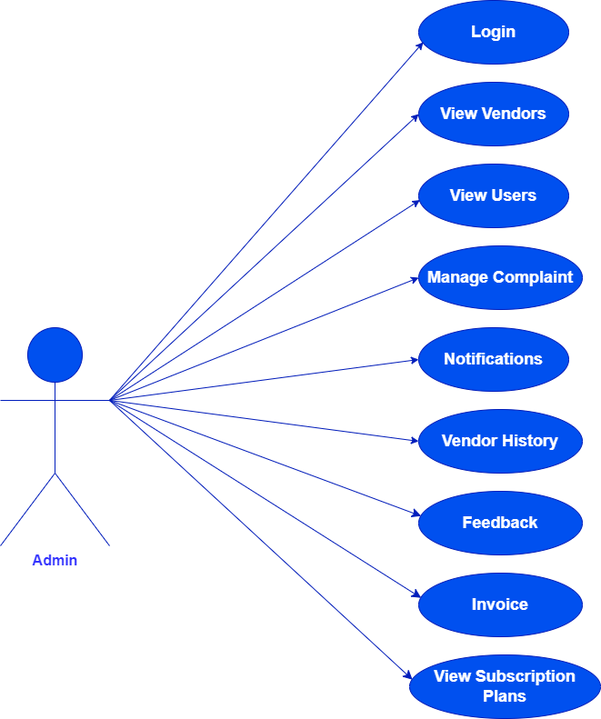

#### User Use Case:

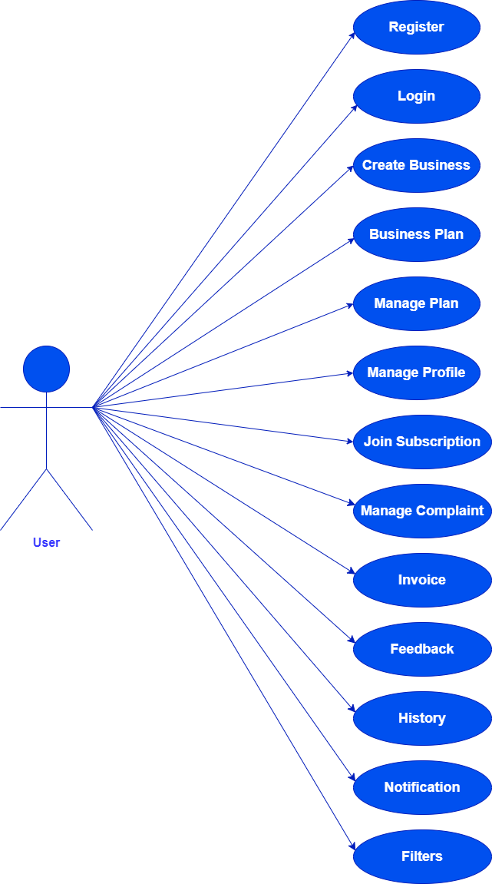

* + 1. **Activity Diagram**

#### Admin Activity:

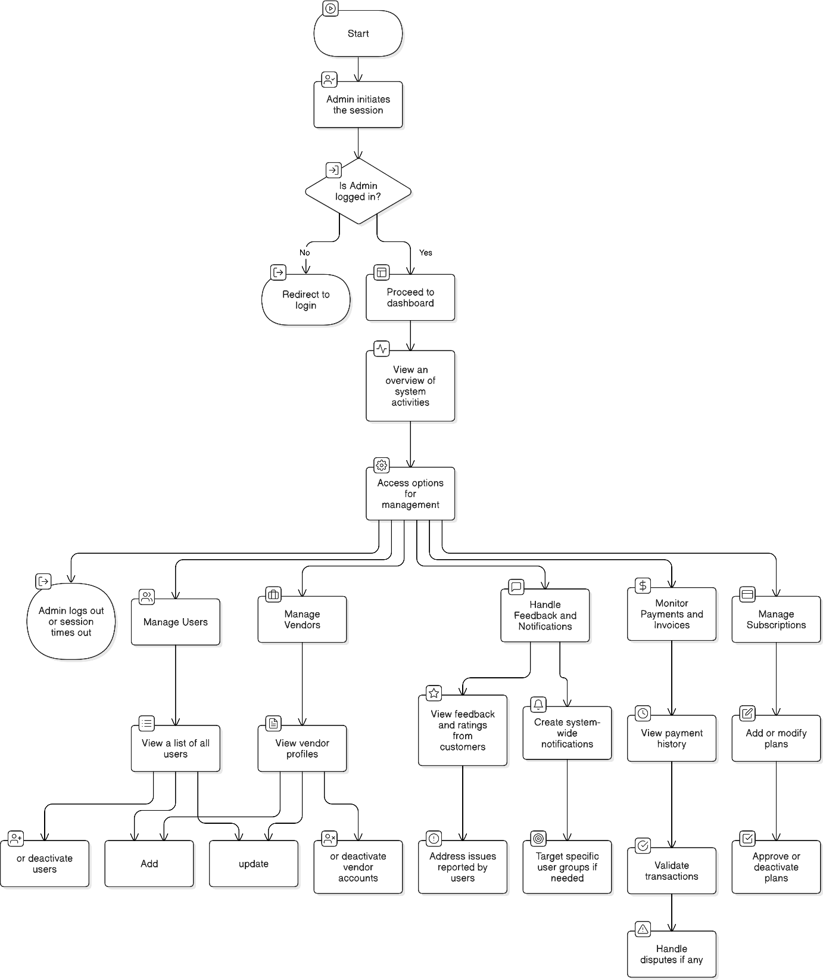

* + - * **User Activity:**

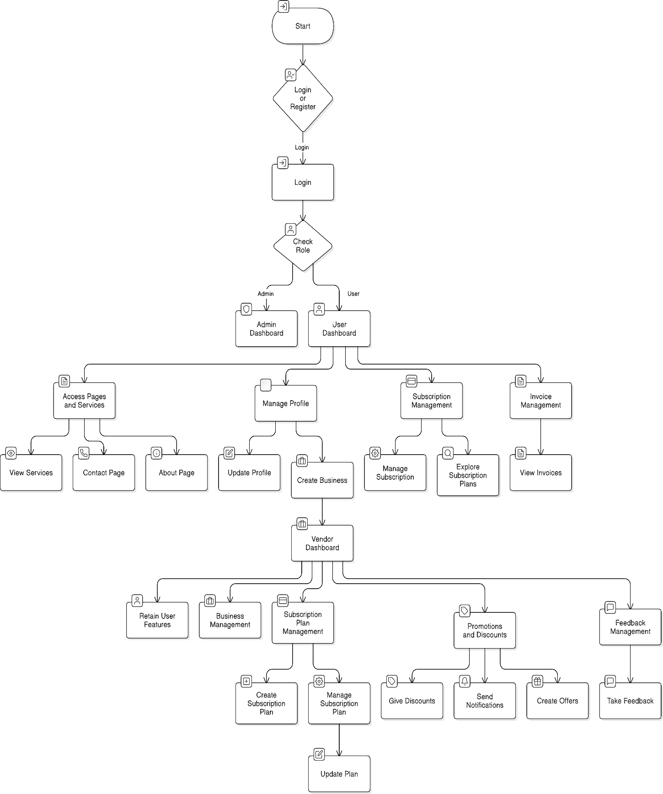

#### Class Diagram

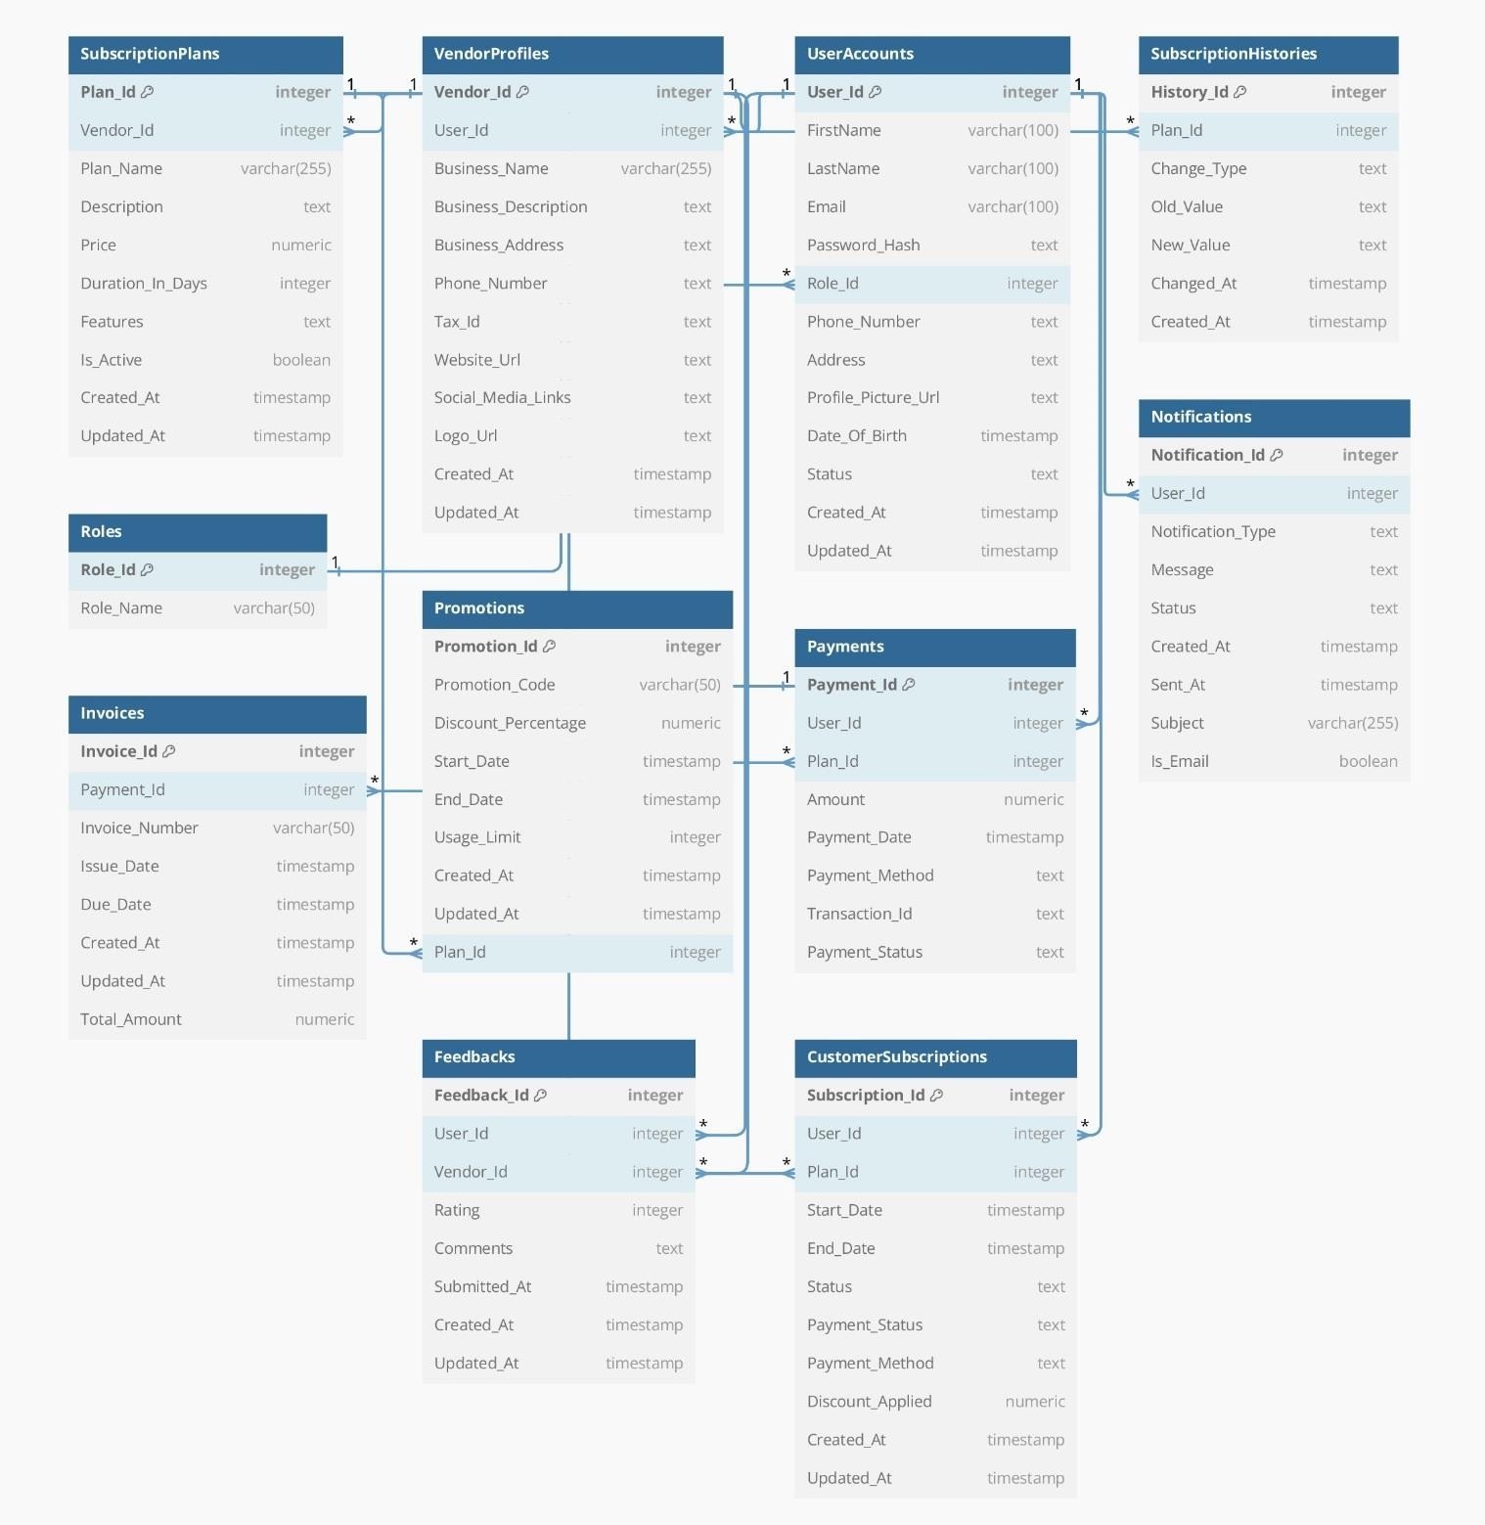

* 1. 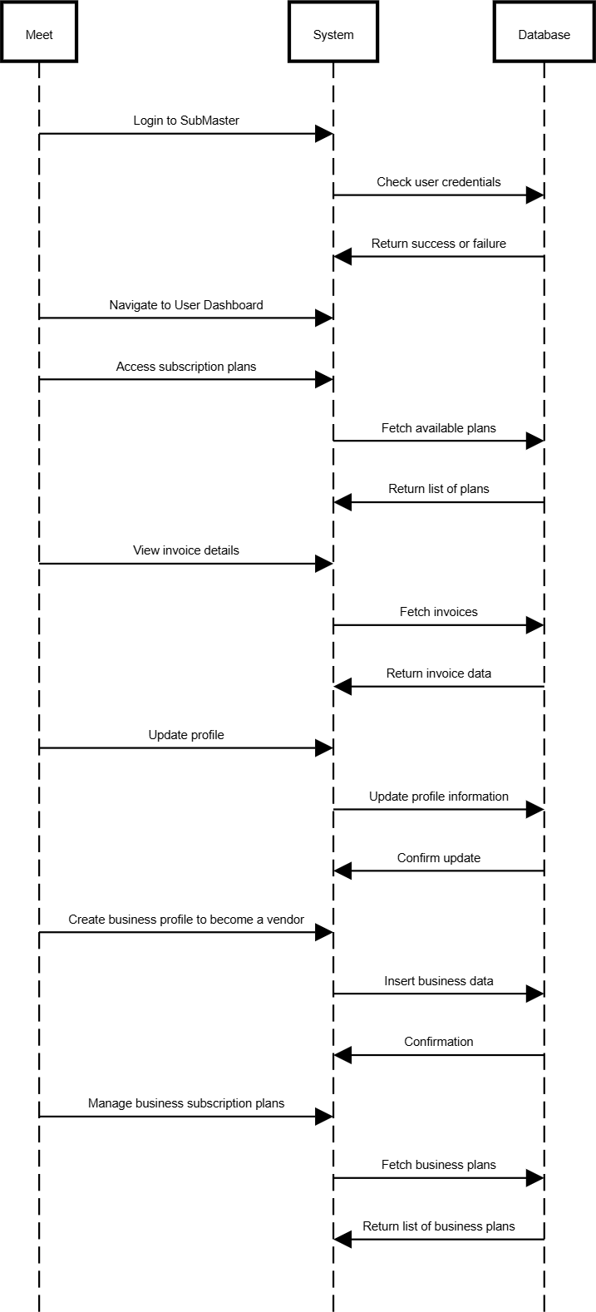**Sequence Diagram User:**

#### Admin:

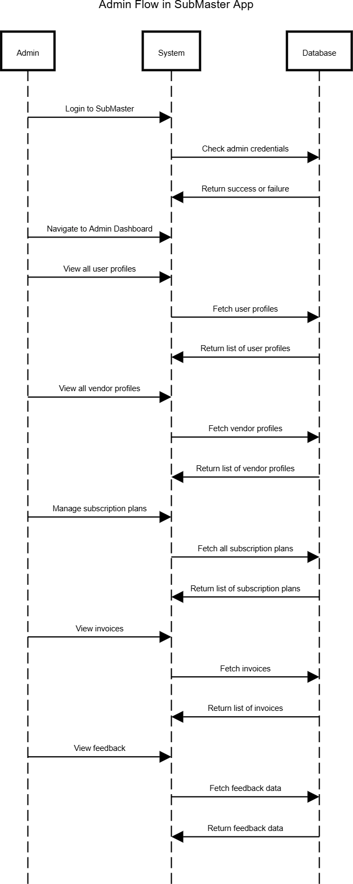

* 1. **E-R Diagram**

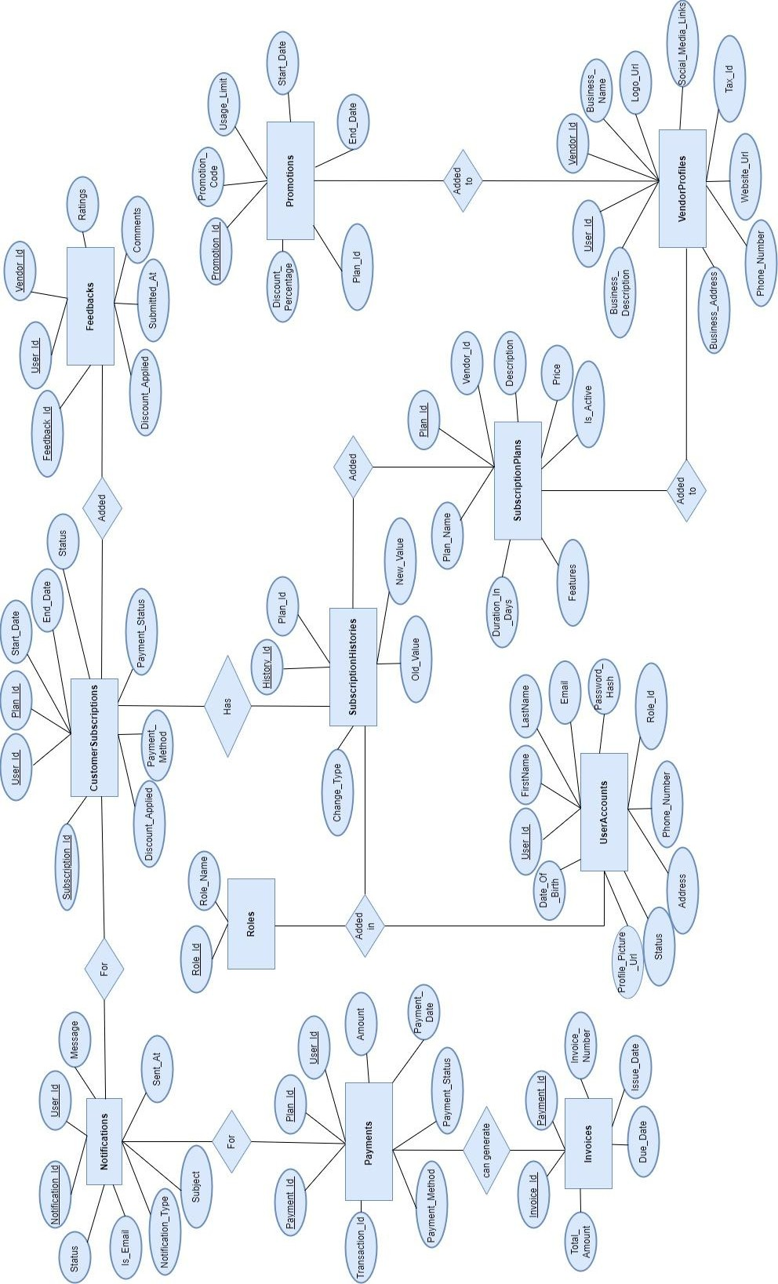

# Software Design

### Database Design

|  |  |  |
| --- | --- | --- |
| **1. Roles** | | |
| **Column Name** | **Data Type** | **Constraint** |
| **Role_Id** | **integer** | **Primary Key** |
| **Role_Name** | **varchar (50)** | **Not Null** |

|  |  |  |
| --- | --- | --- |
| **2. UserAccounts** | | |
| **Column Name** | **Data Type** | **Constraint** |
| **User_Id** | **integer** | **Primary Key** |
| **FirstName** | **varchar(100)** | **Not Null** |
| **LastName** | **varchar(100)** | **Not Null** |
| **Email** | **varchar(100)** | **Not Null** |
| **Password_Hash** | **text** | **Not Null** |
| **Role_Id** | **integer** | **Foreign Key** |
| **Phone_Number** | **text** |  |
| **Address** | **text** |  |
| **Profile_Picture_Url** | **text** |  |
| **Date_Of_Birth** | **timestamp** |  |
| **Status** | **text** | **Not Null** |
| **Created_At** | **timestamp** | **Not Null** |
| **Updated_At** | **timestamp** | **Not Null** |

|  |  |  |
| --- | --- | --- |
| **3. VendorProfiles** | | |
| **Column Name** | **Data Type** | **Constraint** |
| **Vendor_Id** | **integer** | **Primary Key** |
| **User_Id** | **integer** | **Foreign Key** |
| **Business_Name** | **varchar(255)** | **Not Null** |
| **Business_Description** | **text** |  |
| **Business_Address** | **text** |  |
| **Phone_Number** | **text** |  |
| **Tax_Id** | **text** |  |
| **Website_Url** | **text** |  |
| **Social_Media_Links** | **text** |  |
| **Logo_Url** | **text** |  |
| **Created_At** | **timestamp** | **Not Null** |
| **Updated_At** | **timestamp** | **Not Null** |

|  |  |  |
| --- | --- | --- |
| **4. SubscriptionPlans** | | |
| **Column Name** | **Data Type** | **Constraint** |
| **Plan_Id** | **integer** | **Primary Key** |
| **Vendor_Id** | **integer** | **Foreign Key** |
| **Plan_Name** | **varchar(255)** | **Not Null** |
| **Description** | **text** |  |
| **Price** | **numeric** | **Not Null** |
| **Duration_In_Days** | **integer** | **Not Null** |
| **Features** | **text** |  |
| **Is_Active** | **boolean** | **Not Null** |
| **Created_At** | **timestamp** | **Not Null** |
| **Updated_At** | **timestamp** | **Not Null** |

|  |  |  |
| --- | --- | --- |
| **5. CustomerSubscriptions** | | |
| **Column Name** | **Data Type** | **Constraint** |
| **Subscription_Id** | **integer** | **Primary Key** |
| **User_Id** | **integer** | **Foreign Key** |
| **Plan_Id** | **integer** | **Foreign Key** |
| **Start_Date** | **timestamp** | **Not Null** |
| **End_Date** | **timestamp** | **Not Null** |
| **Status** | **text** | **Not Null** |
| **Payment_Status** | **text** | **Not Null** |
| **Payment_Method** | **text** | **Not Null** |
| **Discount_Applied** | **numeric** |  |
| **Created_At** | **timestamp** | **Not Null** |
| **Updated_At** | **timestamp** | **Not Null** |

|  |  |  |
| --- | --- | --- |
| **6. Payments** | | |
| **Column Name** | **Data Type** | **Constraint** |
| **Payment_Id** | **integer** | **Primary Key** |
| **User_Id** | **integer** | **Foreign Key** |
| **Plan_Id** | **integer** | **Foreign Key** |
| **Amount** | **numeric** | **Not Null** |
| **Payment_Date** | **timestamp** | **Not Null** |
| **Payment_Method** | **text** | **Not Null** |
| **Transaction_Id** | **text** | **Not Null** |
| **Payment_Status** | **text** | **Not Null** |
|  |  |  |

|  |  |  |
| --- | --- | --- |
| **7. Invoices** | | |
| **Column Name** | **Data Type** | **Constraint** |
| **Invoice_Id** | **integer** | **Primary Key** |
| **Payment_Id** | **integer** | **Foreign Key** |
| **Invoice_Number** | **varchar(50)** | **Not Null** |
| **Issue_Date** | **timestamp** | **Not Null** |
| **Due_Date** | **timestamp** | **Not Null** |
| **Created_At** | **timestamp** | **Not Null** |
| **Updated_At** | **timestamp** | **Not Null** |
| **Total_Amount** | **numeric** | **Not Null** |

|  |  |  |
| --- | --- | --- |
| **8. Promotions** | | |
| **Column Name** | **Data Type** | **Constraint** |
| **Promotion_Id** | **integer** | **Primary Key** |
| **Promotion_Code** | **varchar(50)** | **Not Null** |
| **Discount_Percentage** | **numeric** | **Not Null** |
| **Start_Date** | **timestamp** | **Not Null** |
| **End_Date** | **timestamp** | **Not Null** |
| **Usage_Limit** | **integer** | **Not Null** |
| **Created_At** | **timestamp** | **Not Null** |
| **Updated_At** | **timestamp** | **Not Null** |
| **Plan_Id** | **integer** | **Foreign Key** |

|  |  |  |
| --- | --- | --- |
| **9. Notifications** | | |
| **Column Name** | **Data Type** | **Constraint** |
| **Notification_Id** | **integer** | **Primary Key** |
| **User_Id** | **integer** | **Foreign Key** |
| **Notification_Type** | **text** | **Not Null** |
| **Message** | **text** | **Not Null** |
| **Status** | **text** | **Not Null** |
| **Created_At** | **timestamp** | **Not Null** |
| **Sent_At** | **timestamp** |  |
| **Subject** | **varchar(255)** | **Not Null** |
| **Is_Email** | **boolean** | **Not Null** |

|  |  |  |
| --- | --- | --- |
| **10. Feedbacks** | | |
| **Column Name** | **Data Type** | **Constraint** |
| **Feedback_Id** | **integer** | **Primary Key** |
| **User_Id** | **integer** | **Foreign Key** |
| **Vendor_Id** | **integer** | **Foreign Key** |
| **Rating** | **integer** | **Not Null** |
| **Comments** | **text** |  |
| **Submitted_At** | **timestamp** | **Not Null** |
| **Created_At** | **timestamp** | **Not Null** |
| **Updated_At** | **timestamp** | **Not Null** |

|  |  |  |
| --- | --- | --- |
| **11. SubscriptionHistories** | | |
| **Column Name** | **Data Type** | **Constraint** |
| **History_Id** | **integer** | **Primary Key** |
| **Plan_Id** | **integer** | **Foreign Key** |
| **Change_Type** | **text** | **Not Null** |
| **Old_Value** | **text** |  |
| **New_Value** | **text** |  |
| **Changed_At** | **timestamp** | **Not Null** |
| **Created_At** | **timestamp** | **Not Null** |

* 1. **Snapshot for the site Register Page: -**

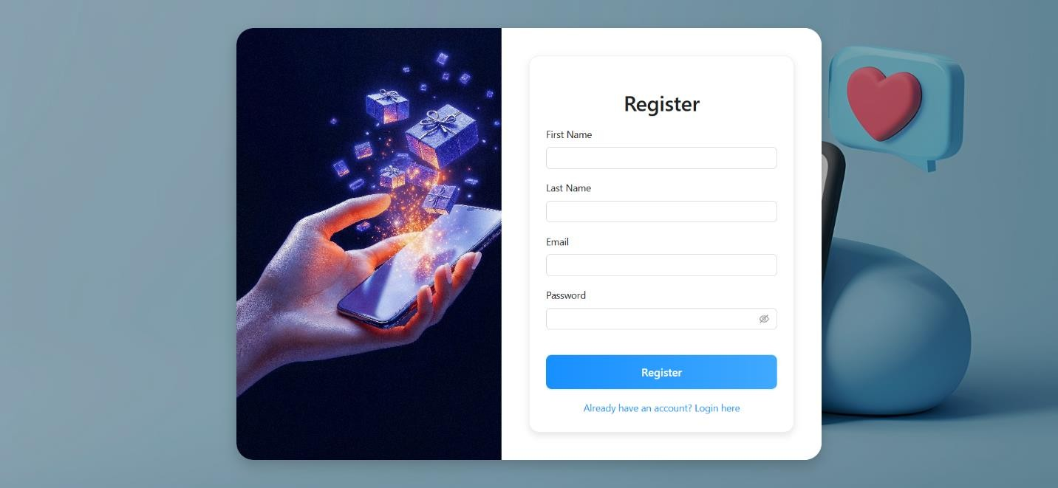

### Login Page: -

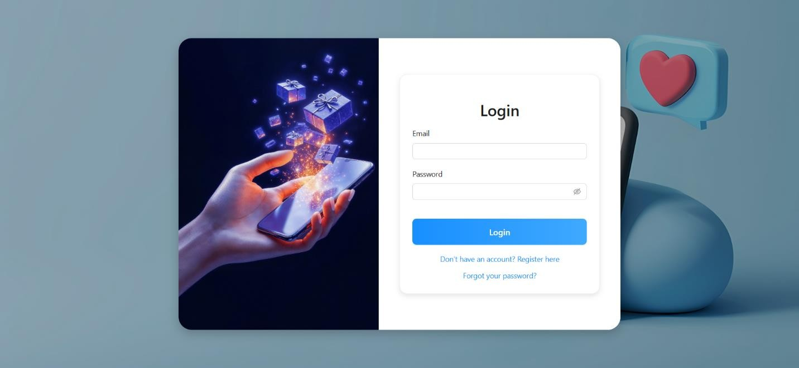

**Forgot Password Page: -**

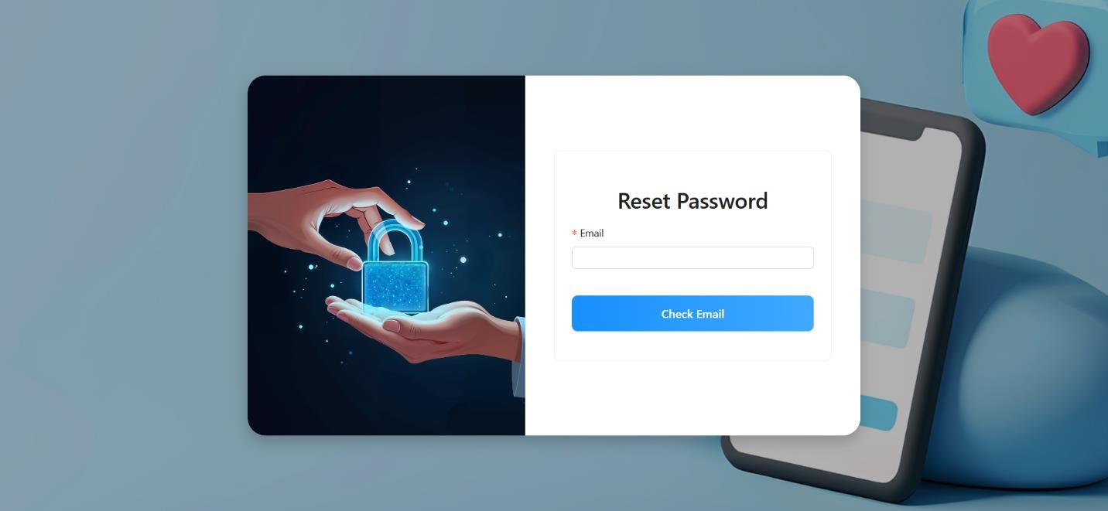

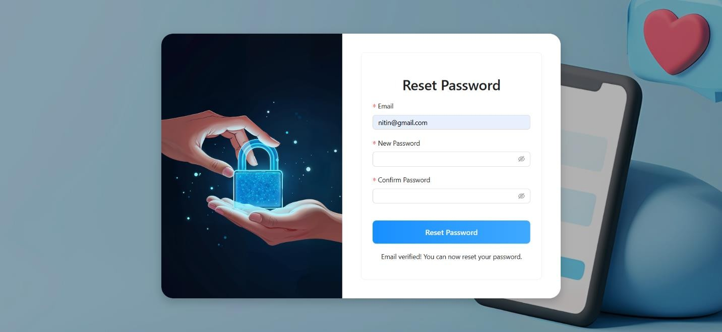

### Home Page: -

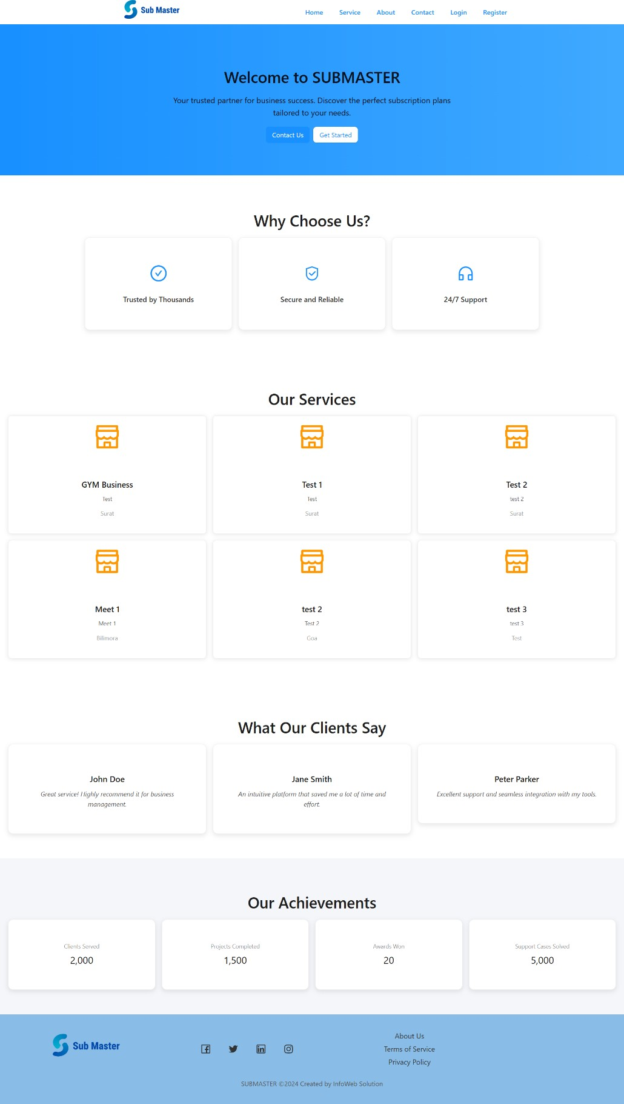

**Service Page: -**

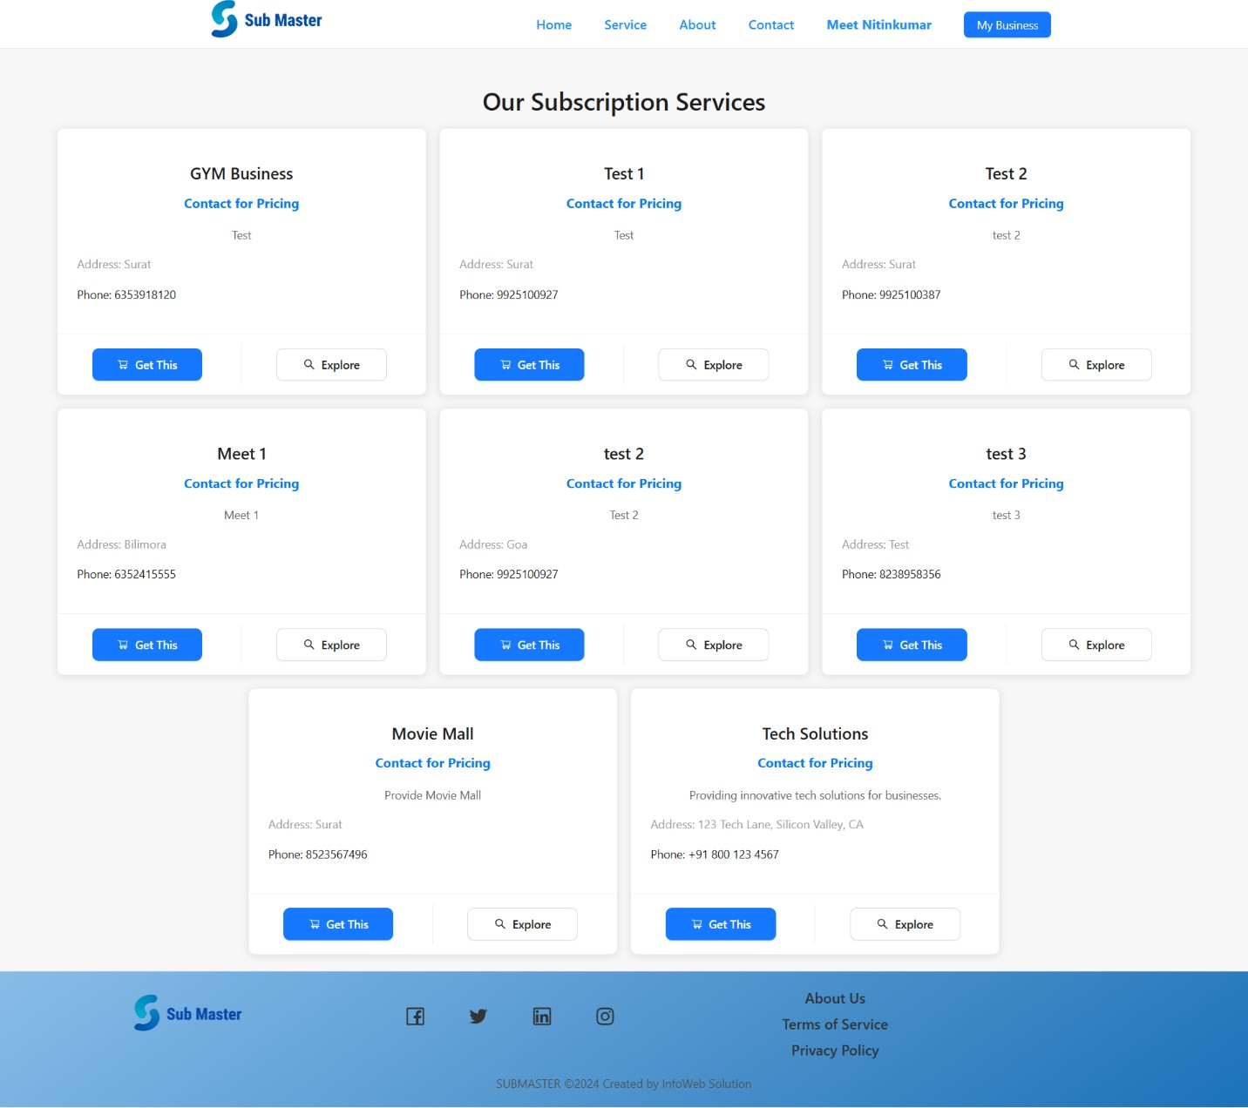

### Explore Plan: -

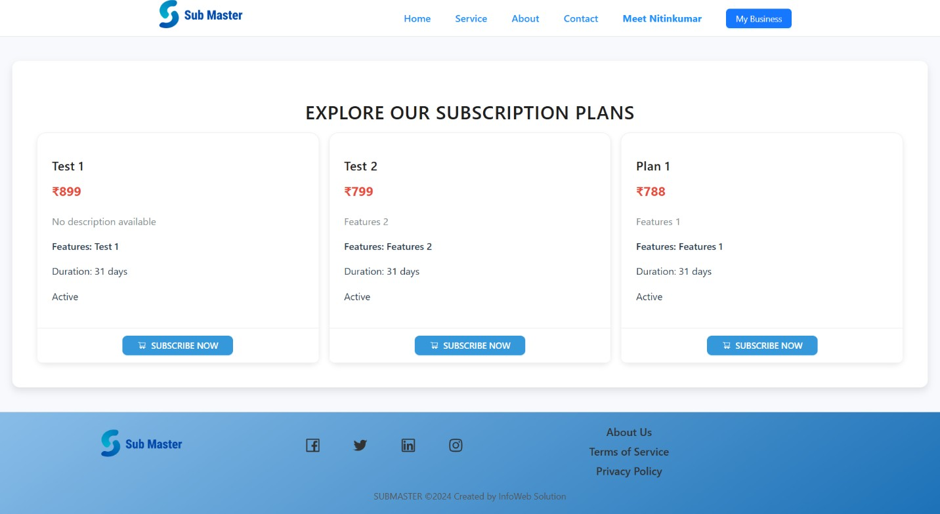

**Plan Details: -**

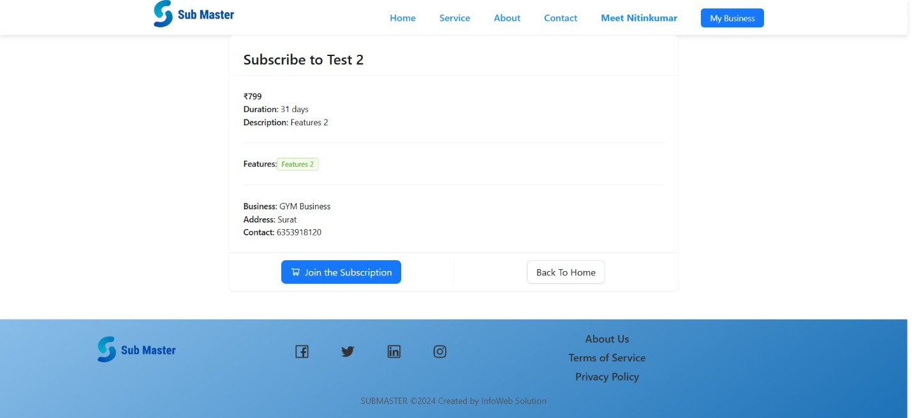

### If Not Plan: -

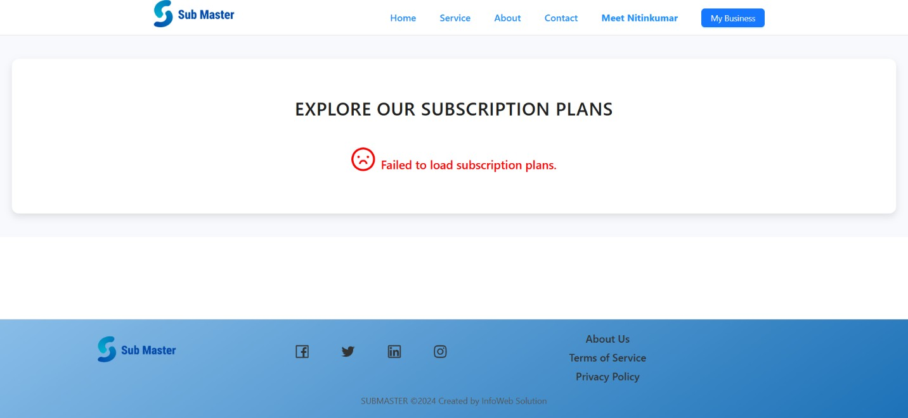

**About Page: -**

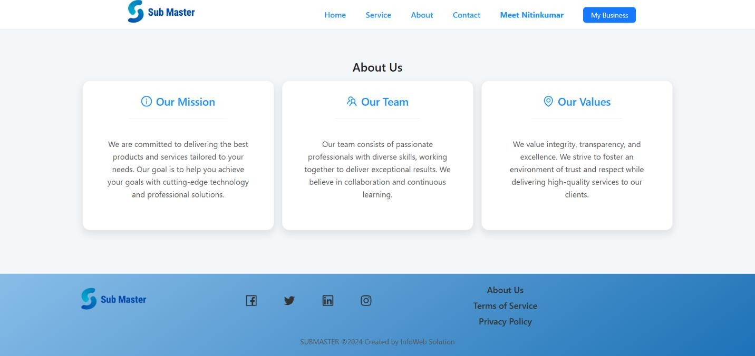

### Contact Page: -

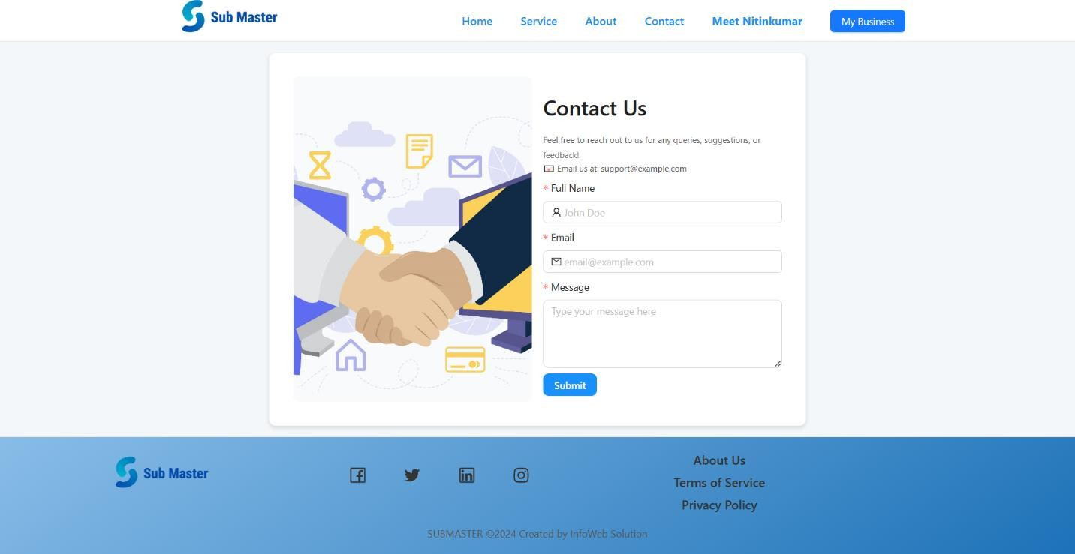

**Profile: -**

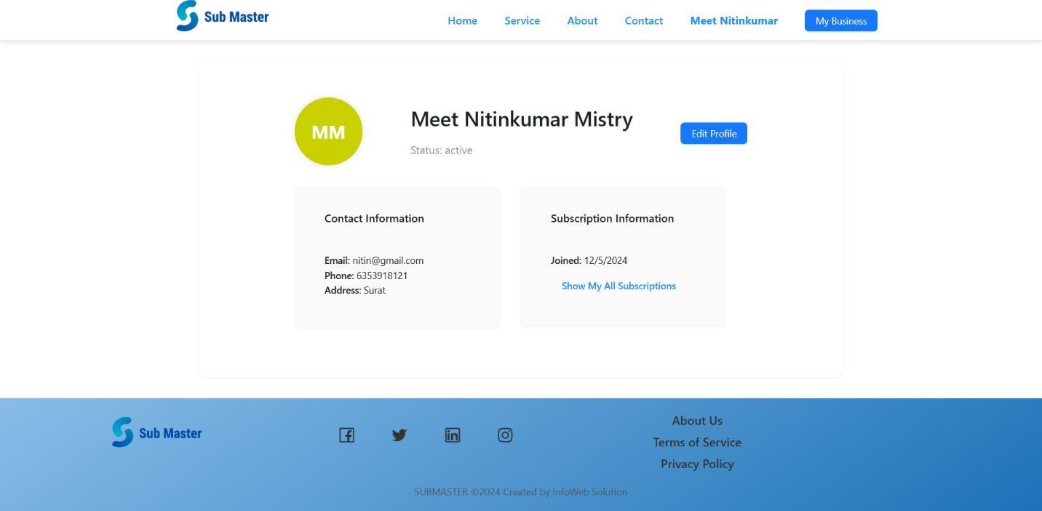

### Edit Profile: -

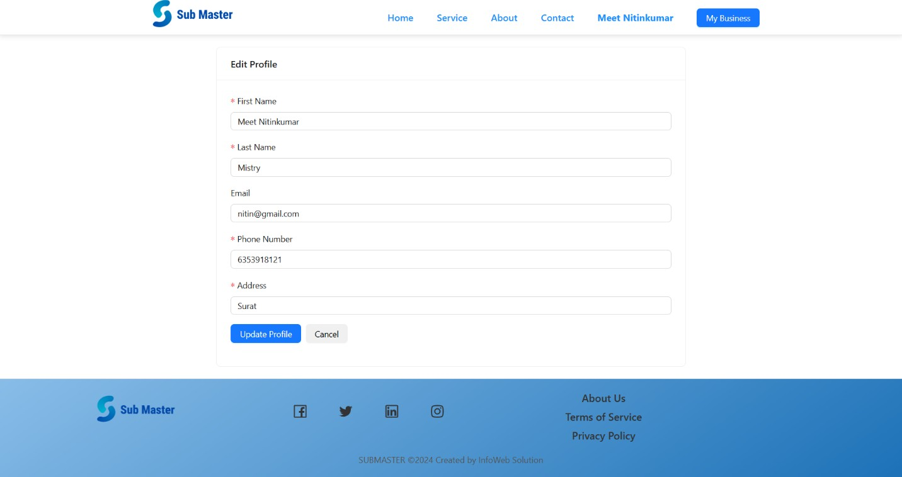

**User All Subscriptions: -**

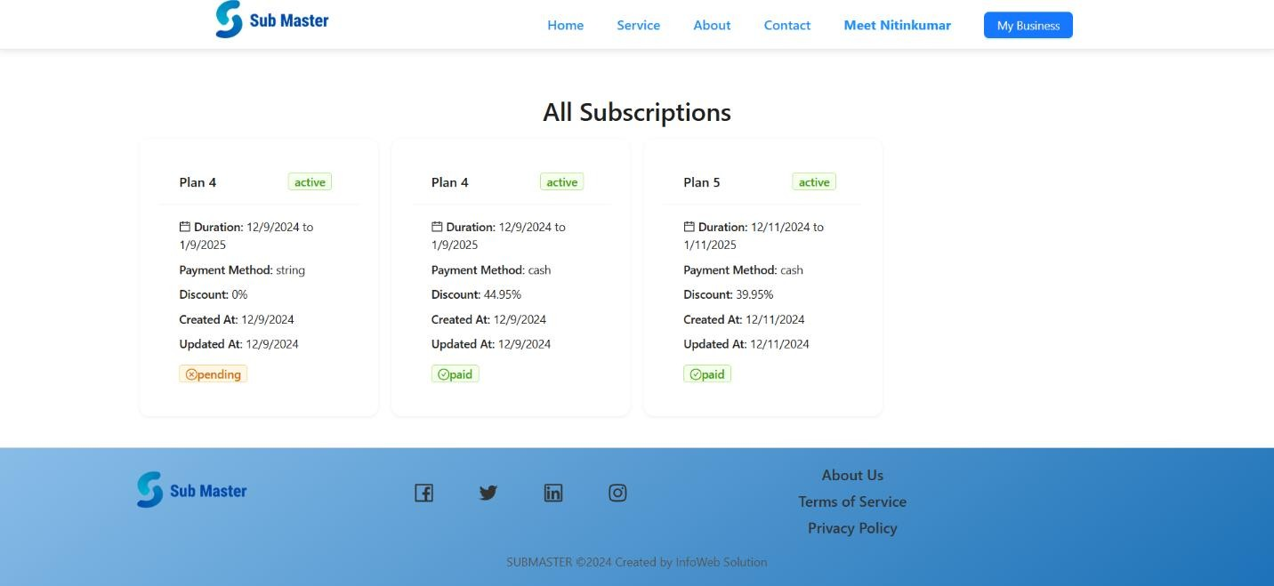

### My Business Page: -

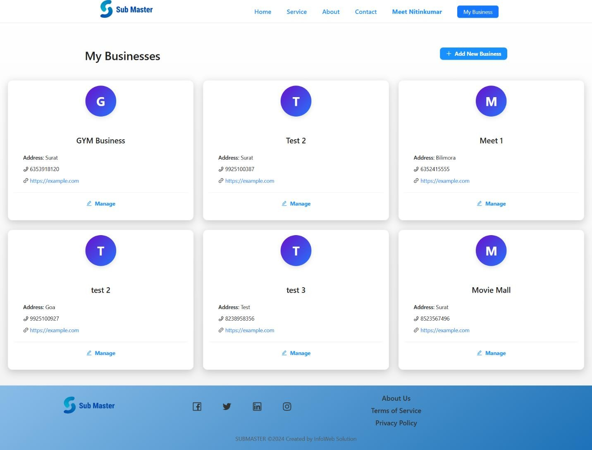

**Add New Business: -**

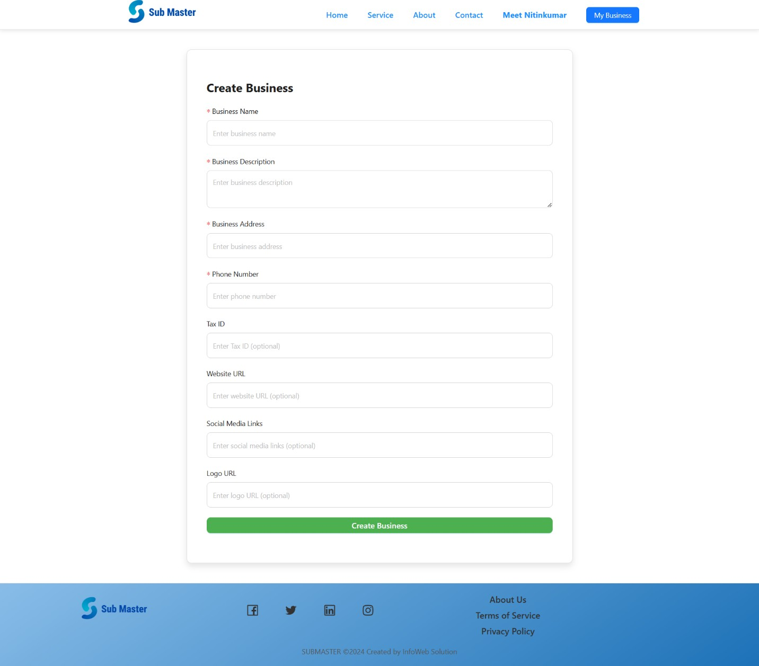

### Manage Business: -

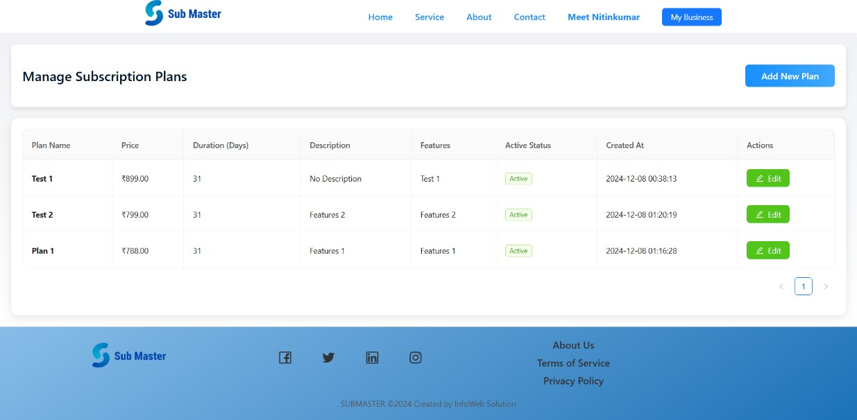

**Add New Business Plan: -**

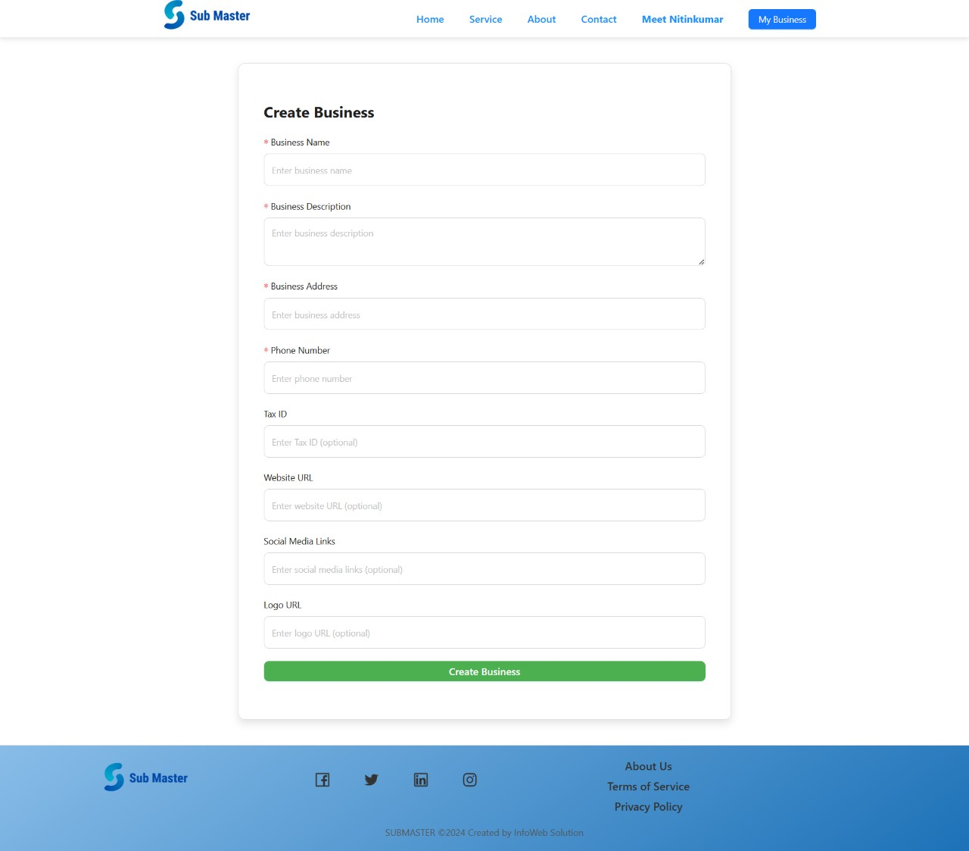

### Admin Dashboard: -

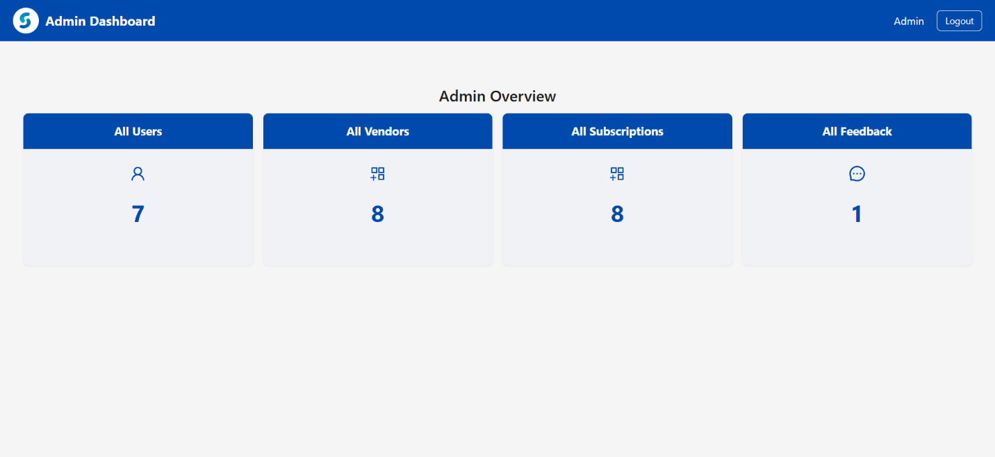

**All Users: -**

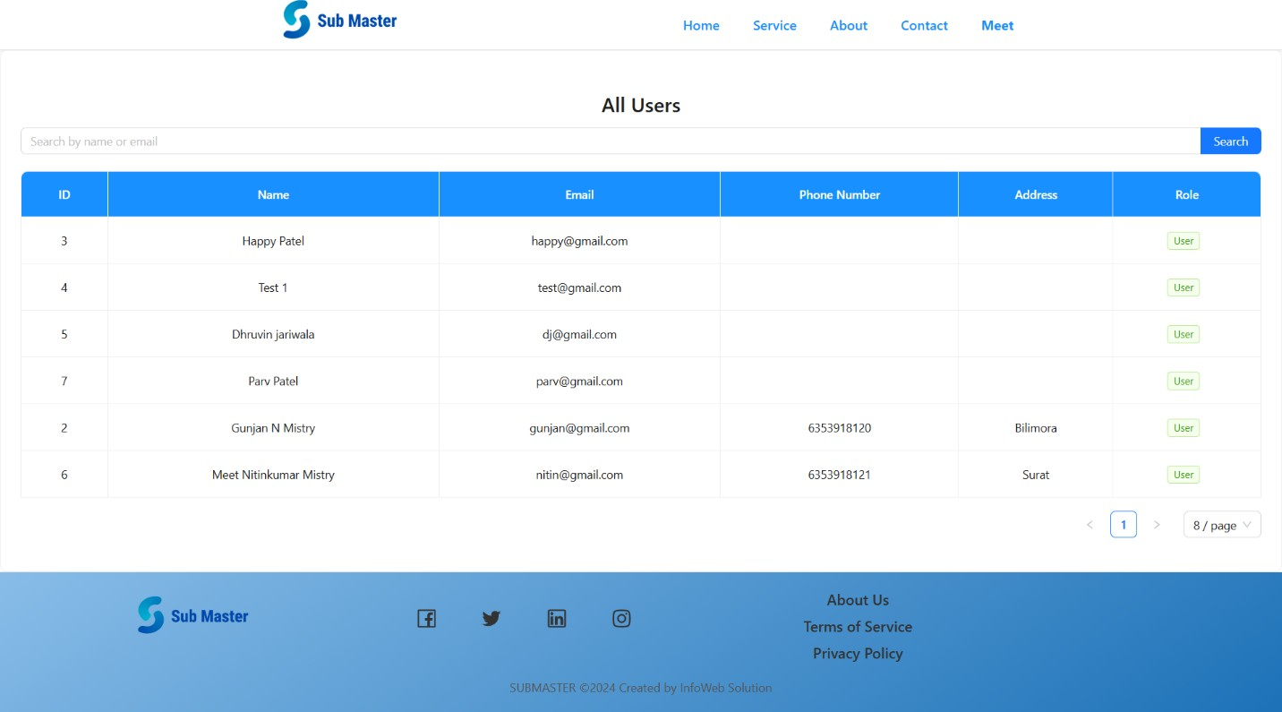

### All Vendors: -

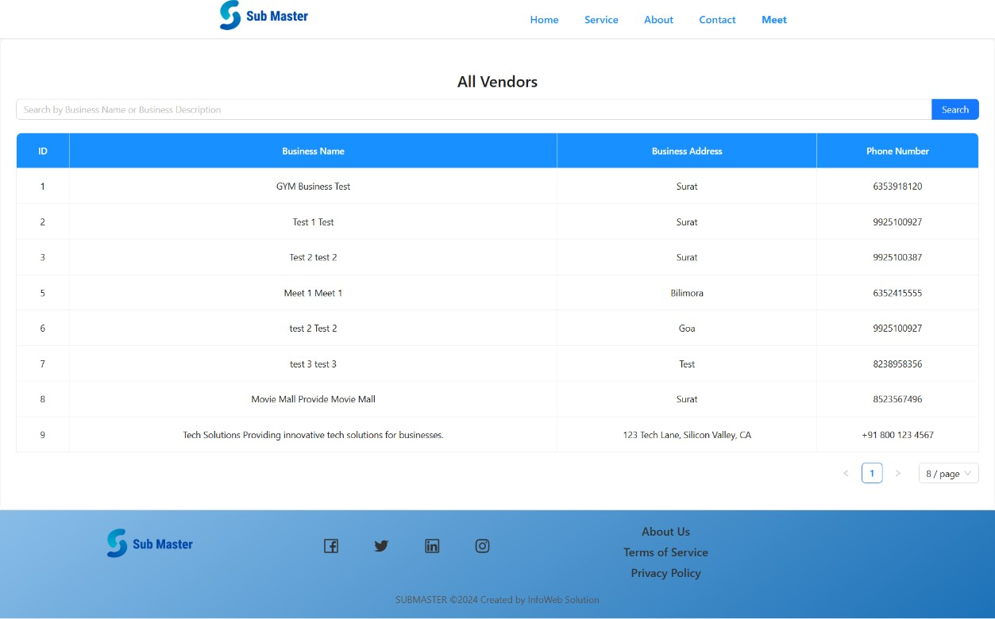

**All Subscriptions: -**

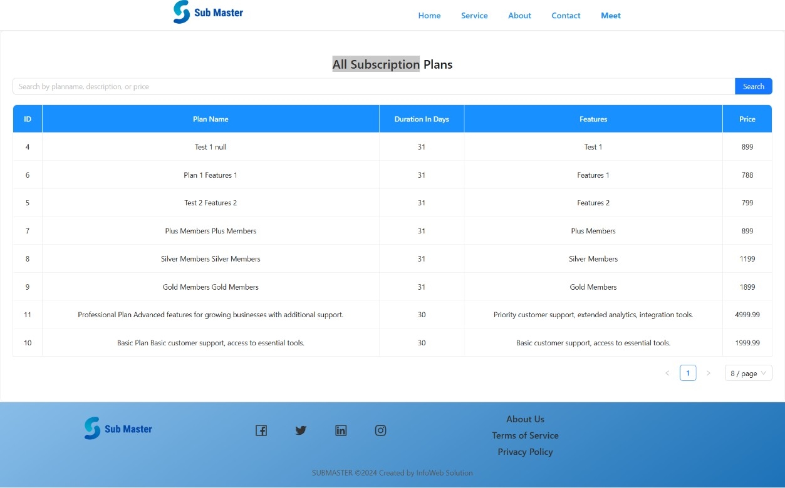

### All Feedback: -

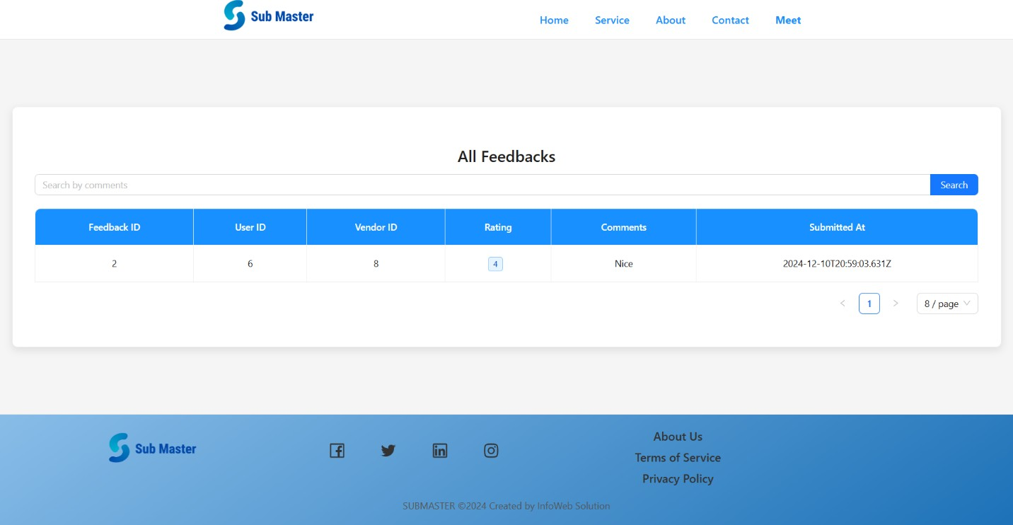

**Error Page: -**

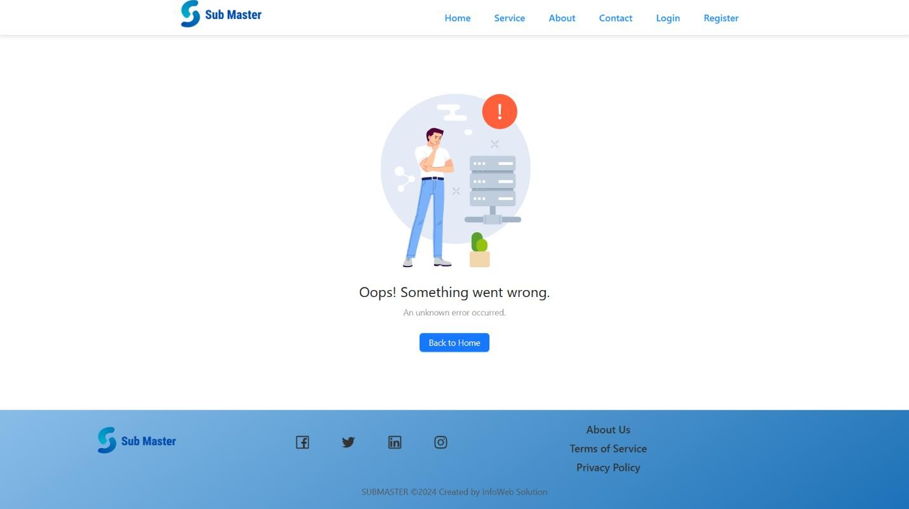

# Testing

### Unit Testing

#### Test Cases for Login

|  |  |  |  |
| --- | --- | --- | --- |
| **Test Case ID** | **Test Field** | **Condition** | **Expected Result** |
| TC-LOGIN- 01 | Email | Valid email and correct password | Successful login |
| TC-LOGIN- 02 | Email | Valid email but incorrect password | Error message: "Invalid credentials" |
| TC-LOGIN- 03 | Email | Invalid email format | Error message: "Invalid email format" |
| TC-LOGIN- 04 | Password | Valid email, encrypted password | Successful login |
| TC-LOGIN- 05 | Password | Password too short (less than 6 characters) | Error message: "Password too short" |

**Test Cases for Registration**

|  |  |  |  |
| --- | --- | --- | --- |
| **Test Case**  **ID** | **Test Field** | **Condition** | **Expected Result** |
| TC-REG- 01 | Email | Valid email format | Successful registration |
| TC-REG- 02 | Email | Invalid email format | Error message: "Invalid email format" |
| TC-REG- 03 | Password | Password too short (less than 6 characters) | Error message: "Password too short" |
| TC-REG-  04 | Password | Encrypted password | Successful registration |

|  |  |  |  |
| --- | --- | --- | --- |
| **Test Case ID** | **Test Field** | **Condition** | **Expected Result** |
| TC-REG- 05 | User Details | All fields valid | New user record created in the database |

#### Test Cases for Forgot Password

|  |  |  |  |
| --- | --- | --- | --- |
| **Test Case ID** | **Test Field** | **Condition** | **Expected Result** |
| TC-FORG-01 | Email | Valid registered email | Password reset email sent |
| TC-FORG-02 | Email | Unregistered email | Error message: "Email not found" |
| TC-FORG-03 | Email | Invalid email format | Error message: "Invalid email format" |

**Test Cases for User Entries**

|  |  |  |  |
| --- | --- | --- | --- |
| **Test Case ID** | **Test Field** | **Condition** | **Expected Result** |
| TC-ACR-01 | Email | Valid email format | Accepts valid email |
| TC-ACR-02 | Password | Valid format | Accepts valid password |
| TC-ACR-03 | Contact Number | Valid number format | Accepts valid contact details |
| TC-ACR-04 | Address | Valid format | Accepts valid address |
| TC-ACR-05 | Role ID | Valid role ID | Accepts valid role |

#### Integration Testing

**Integration Between Backend and Frontend**

|  |  |  |
| --- | --- | --- |
| **Test Case ID** | **Steps** | **Expected Outcome** |
| INTG-BEFE- 01 | 1. Enter valid credentials in the frontend. 2. Submit login request to backend. 3. Backend authenticates and responds. 4. Frontend updates the UI accordingly. | User successfully logged in |
| INTG-BEFE- 02 | 1. Fill the registration form in the frontend. 2. Submit registration request. 3. Backend creates a new user record and responds. 4. Frontend confirms successful registration. | User registered successfully |
| INTG-BEFE- 03 | 1. Request a password reset in the frontend. 2. Frontend sends request to the backend. 3. Backend sends reset email instructions. 4. User resets their password. | Password reset email successfully sent |

# Future Enhancements

### Personalization and Analytics

* + - **AI-driven Recommendations:** Utilize machine learning algorithms to suggest personalized subscription plans based on user preferences, browsing history, and usage patterns.
    - **Advanced Dashboards:** Interactive dashboards with detailed analytics on user engagement, retention, and churn. Provide predictive insights to identify at-risk users and suggest retention strategies.
    - **Behavioural Insights:** Leverage analytics tools like Google Analytics and Mix panel to track user behaviour and refine personalization.

#### Flexibility and User Experience

* + - **Pay-as-you-go Options:** Offer flexible payment plans, enabling users to pay only for the features they use.
    - **Multi-Plan Support:** Allow users to subscribe to and manage multiple plans within the same account.
    - **Mobile App:** A feature-rich mobile app for iOS and Android, offering:
    - Quick subscription management on the go.
    - Real-time notifications about payments, renewals, and offers.
    - Offline access to essential subscription details.
    - **Animations:** Enhance user engagement with smooth UI animations for transitions, loading screens, and interactive elements like subscription cards.
    - **City Filters:** Enable users to filter subscriptions and services based on city or region for localized offerings.

#### Globalization and Security

* + - **Multi-language Support:** Enable localization with support for multiple languages to cater to diverse global audiences.
    - **Multi-currency Transactions: Provide** seamless payment options in various currencies, ensuring a hassle-free experience for international users.

#### Advanced Security Measures:

* + - * Implement two-factor authentication for account security.
      * Ensure compliance with GDPR, PCI DSS, and other global security standards.
      * Use data encryption for sensitive information like payment details.

#### Integration and Automation

* + - **Third-Party Integrations:**
      * Connect with AWS and Supa-base for cloud-based storage, database management, and serverless computing.
      * Integrate with payment gateways like Stripe and PayPal.
      * Link with CRM and marketing tools like HubSpot and Mailchimp for seamless workflows.
    - **Automated Workflows:** Streamline subscription renewals with automated reminders and

payment processing.

* + - **Email Notifications:** Automated email alerts for:
    - Welcome emails for new subscribers.
    - Payment receipts and renewal confirmations.
    - Special offers and updates.
    - **In-App Notifications:** Real-time notifications for subscription updates, payment issues, and exclusive deals.

#### Scalability and Performance

* + - **Cloud Infrastructure:** Transition to scalable cloud solutions using AWS for elastic computing and Supa-base for real-time database capabilities.
    - **Microservices Architecture:** Use microservices to modularize application components, ensuring faster deployment and easier maintenance.
    - **High Performance:** Optimize system architecture for high-speed data processing, even under heavy load.

#### Advanced Features

* + - **Family and Group Plans: Allow** users to share subscriptions with family members or groups, with options to customize member permissions.
    - **Gifting Options:** Provide the ability for users to gift subscriptions to others with personalized messages and scheduled delivery.
    - **City-Based Services:** Tailor services and offerings based on the user’s city, providing hyper-localized content.
    - **Image Uploads:** Enable users to upload and manage images for personalized profiles or subscription-related documents.

#### Advanced Mobile App Features:

* + - * Push notifications for important updates.
      * A visually appealing design with modern animations.
      * Integrated city filters to provide location-based services directly on the app.

# Glossary

|  |  |
| --- | --- |
| **Term** | **Definition** |
| **Admin** | A user role responsible for managing subscription plans, user accounts, payments, and overall administrative tasks. |
| **Subscription Plan** | A defined package offering access to various services within the system, available for user selection. |
| **Subscriber** | A user who has subscribed to a plan and enjoys its benefits based on the active subscription. |
| **Payment Gateway** | A service that processes payments for subscription renewals and new sign-ups. |
| **Backend** | The server-side component of the Subscription Management System responsible for managing subscription data, payments, and API endpoints, implemented using Dotnet Core. |
| **Frontend** | The client-side part of the application that interacts with users, displaying subscription details, managing user inputs, and processing payments. It’s implemented using React for web applications and Flutter for mobile. |
| **User Role** | A classification within the system that defines the permissions and actions a user can perform, such as Admin, Subscriber, or Guest. |
| **Subscription Renewal** | The process by which a subscriber’s active plan is extended after its expiration. |
| **Payment** | A transaction made by the subscriber to initiate or renew a subscription plan. |
| **Payment Confirmation** | A notification or receipt confirming that a subscriber's payment has been successfully processed. |
| **Subscription History** | A log that tracks all past subscriptions, renewals, and cancellations of a user. |
| **API** | Application Programming Interface; used for communication between  the frontend and backend in the system. |

|  |  |
| --- | --- |
| **Term** | **Definition** |
| **Authentication** | The process of verifying a user’s identity when accessing the system.  Typically done through login credentials or OAuth tokens. |
| **Authorization** | The process of granting a user access to specific features based on their role or subscription level. |
| **JWT Token** | JSON Web Token; used to securely transfer authentication and authorization details between the client and server. |
| **Subscription Metrics** | Analytics and reports on subscriber behavior, including plan choices, usage, and renewal patterns. |
| **Trial Period** | A temporary, free access period given to new users to explore subscription benefits before making a purchase decision. |
| **Cancelation** | The action by which a user ends their subscription before its natural expiration, often with consequences like data loss or restricted access. |
| **Auto-Renewal** | A feature that automatically renews a subscription plan at the end of the billing cycle unless canceled by the user. |
| **Invoice** | A document generated to summarize a subscription transaction, including pricing, tax, and payment details. |
| **Email Notification** | Automated emails sent to users regarding their subscription status, payment reminders, or promotional offers. |
| **Plan Upgrade/Downgrade** | The ability for subscribers to change to a different subscription plan, either with more or fewer benefits. |
| **Customer Support** | A service provided to help subscribers with issues related to subscriptions, payments, or technical difficulties. |
| **Subscription Tier** | Different levels or categories of subscription plans, each with its own set of benefits and pricing. |
| **Refund** | The process of returning money to a subscriber when they cancel their  plan within the allowed period or under specific conditions. |

|  |  |
| --- | --- |
| **Term** | **Definition** |
| **Discount Code** | A promotional code that gives users a reduced price on subscription plans or services. |
| **API Rate Limiting** | A mechanism used to control the number of requests made to the backend API to prevent system overload. |
| **Subscription Dashboard** | A user interface that displays a subscriber’s plan details, payment status, and other relevant subscription information. |
| **Renewal Reminder** | Automated notifications sent to subscribers to remind them of an upcoming subscription renewal. |

**Reference**

* [**https://www.figma.com/**](https://www.figma.com/)
* [**https://jwt.io/**](https://jwt.io/)
* [**https://medium.com/thesignalgroup**](https://medium.com/thesignalgroup)
* [**https://learn.microsoft.com/en-us/aspnet/core/?view=aspnetcore-**](https://learn.microsoft.com/en-us/aspnet/core/?view=aspnetcore-8.0&WT.mc_id=dotnet-35129-website)

[**8.0&WT.mc_id=dotnet-35129-website**](https://learn.microsoft.com/en-us/aspnet/core/?view=aspnetcore-8.0&WT.mc_id=dotnet-35129-website)

* [**https://www.npmjs.com/**](https://www.npmjs.com/)
* [**https://formik.org/docs/overview**](https://formik.org/docs/overview)
* [**https://ant.design/**](https://ant.design/)
* [**https://vite.dev/guide/**](https://vite.dev/guide/)